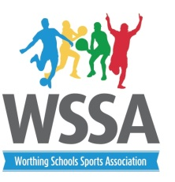
Year 6 Netball (Non rotational)
Cup and Shield 2020
Tuesday 28th January 3.45pm
Worthing College
Pool A – Cup
- Durrington
- TAB A (blue)
- Goring
- West Park
- Chesswood A(red)

Pool B - Plate
- English Martyrs
- TAB B (white)
- St Mary’s
- Heene
- Chesswood B (blue)

Time | Court 1 | Court 2 | Court 3 | Court 4
3.45pm | 1v4 | 2v3 | 1v4 | 2v3
4.00pm | 3v1 | 4v5 | 3v1 | 4v5
4.15pm | 5v3 | 1v2 | 5v3 | 1v2
4.30pm | 2v5 | 3v4 | 2v5 | 3v4
4.45pm | 4v2 | 5v1 | 4v2 | 5v1
5.00pm | Presentation of medals and trophies

Rules
- Please ensure you arrive in plenty of time to play at your allocated time and court.
- This is NON Rotational netball. You may have 2 Boys in your squad.
- Matches will be played with lower posts (9ft) 4 second rule. Players will also be allowed to defend providing they are 1M away.
- Matches 6 min EACH way and 3 min between games
- Staff will need to umpire their own games
- The pools have been allocated on the size of the school as well as B teams. Medals will be awarded to the winners of each pool in the Cup and Shield. If however teams drop out then we will go back to ONE competition.

