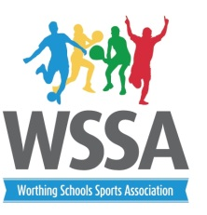
Year 6 Central venue Netball Leagues

Chesswood

- Downsbrook
- Broadwater
- St Mary’s
- Chesswood A
- Chesswood B
- TAB Juniors

West Park
- West Park A
- Vale
- Orchards
- English Martyrs
- Durrington
- West Park B

Date | Time | Court 1 | Court 2 | Court 3
6th October | 3.45pm | 1v2 | 3v4 | 5v6
 | 4.10pm | 1v3 | 2v5 | 4v6
 | 4.35 pm | 1v4 | 2v6 | 3v5
13th October | 3.45pm | 1v5 | 2v4 | 3v6
 | 4.10pm | 1v6 | 2v3 | 4v5
 | 4.35pm | Results and venues allocated
20th October |  | Cup and Plate competitions

Rules
- High 5 netball rules apply with 7 player rotation. All schools will need 7 players.
- Schools must continue rotations throughout the afternoon
- Matches 8 min each way. 2 min at half time.
- Staff will need to umpire their own games
- First 3 teams in each pool will qualify for the cup finals – the remaining teams for the plate. These venues will be allocated once results are in. For the final week schools will play a round robin
- Please ensure no jewellery is worn.

