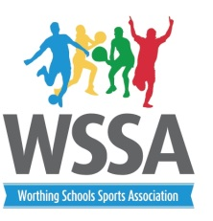
Year 5 /6 Basketball tournament
Thursday 23rd January 2020
St Andrews High School 3.45pm -5.05pm
Basic rules
- Up to 10 players in a squad with 5 on the court at one time.
- At least 2 girls on court at any time.
- Matches will be 8 min one way with 2 min between games.
- Substitutions may be made when the ball is out of play
- Referees decision is final
- Players to wear non marking footwear
- 3 points for a win and 1 for a loss
Boys from St Andrews will be refereeing but please be prepared to step in , if needs be. Thank you.
Pool A
1. TAB A – Blue
2.English Martyrs
3. Whytemead
4.Chesswood B –Red
Pool B
1. TAB B -white
2. Chesswood A blue
3. Bramber
4. St Mary’s
Order of play
Time | Court 1 (pool A) | Court 2 (Pool B)
3.45pm | 1v2 | 1v2
3.55pm | 3v4 | 3v4
4.05pm | 1v3 | 1v3
4.15pm | 4v2 | 4v2
4.25pm | 1v4 | 1v4
4.35pm | 2v3 | 2v3
4.45pm | 3rd Pool A V 3rd Pool B | 4th pool A V 4th Pool B
4.55pm | 1st Pool A v 1st Pool B | 2nd Pool A V 2nd Pool B
5.05pm | Results and presentation

