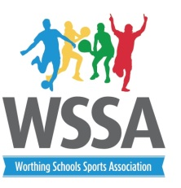
Year 5/6 Basketball rules

- Up to 10 players in a squad with 5 on the court at one time.
- At least 2 girls on court at any time.
- Matches will be 7 min one way with 3 min between games.
- Substitutions may be made when the ball is out of play
- Referees decision is final
- Players to wear non marking footwear
- 3 points for a win and 1 for a loss

Match Rules
Fouls: Players will be penalised by a free throw from the side of the court for:
• Travelling with the ball (moving without bouncing the ball one-handed).
• Holding the ball for more than 5 seconds, whilst not dribbling.
• Minor contact with an opposition player (e.g. when a player is not in the act of shooting a basket)
• Double dribbling the ball. (Once a player stops dribbling with one hand (s)he is not allowed to dribble again. If a player does more than 1 two-handed bounce at any stage, this is a “double dribble”).
• 1 Free shot (worth 2 points) will called if contact is made as an opposition player is in the act of shooting for a basket. 1 free shot (worth 1 point) will be called if a player is fouled when shooting but the shot goes in anyway.
Free throws will be taken from the nearest line in front of the basket.
- The ball will be deemed out of play if it goes outside the playing area or touches the wall behind the basket.

Rules which will NOT apply in this tournament:
As there will be no “key”, there will be no 3-second rule.
There will be no 1/2 court rule (teams are allowed to pass from front court to back court)
There will be no 3-point shots called, no matter how far away the shot is taken from.
Players will not have a foul count against them, although if the referee deems a player to be continually guilty of foul play or dangerous play, he may request that the player be substituted.
2 points will be awarded for a basket.

Please encourage fair play amongst players. .

