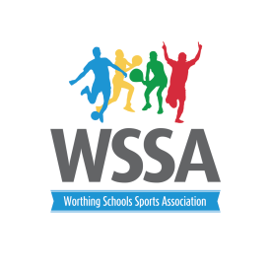
Year 4 Gymnastics Competition Team Declaration
School……………………………………………………..
 | Name | year group | Boy/Girl
1.

2

3

4

5.

6.
7.

8.

Schools may have up to 8 children in a squad with the 6 best results counting towards the overall score. If you have boys in your team then you will be awarded 0.5 for each boy up to 2 boys competing. i.e. 1 mark. Additional boys may compete but WILL NOT score the additional 0.5.

Signed ................................................................. Date ..............................................

