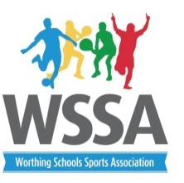

Order of Play
Year 3/4 Street Cricket 2019

- TAB (red) A
- TAB (blue) B
- Bramber
- Broadwater
- Chesswood
- Goring
- Laurels

Time | Pitch 1 | Pitch 2
14th May 3.20 | 1v6 | 2v4
3.40 | 3v4 | 5v1
4.00 | 5v2 | 6v7
4.20 | 2v7 | 3v6
4.40 | 4v5 | 6v2
 | 3v1
21st May 3.20 | 5v3 | 7v1
3.40 | 2v3 | 4v7
4.00 | 5v6 | 1v2
4.20 | 6v4 | 7v3
4.40 | 7v5 | 1v4
 | Presentations

