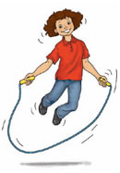
Playground Challenges

Skipping

You will need
Skipping ropes
Stopwatch
Clipboard and record sheet
A safe space

Challenges
How many skips forwards can you do without stopping?
How many skips BACKWARDS can you do without stopping?
How many skips can you do in 1 min?

Write down the results on your record sheet.

Skipping
Name | Skips forward | Skips backwards | Skips in 1 min

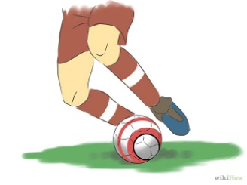
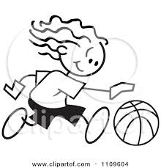
Playground Challenges

Dribbling
You will need
5 cones which are set up 2M apart in a straight line
1 medium ball (bouncy)
1 football
1 plastic hockey stick
1 small airflow ball
Stopwatch
Challenges
How fast can you dribble the ball using your FEET from the start line in and out of the cones and back to the finish?
How fast can you dribble the ball by bouncing it with ONE HAND from the start line in and out of the cones and back to the finish?
How fast can you dribble the ball using a Hockey stick and a ball from the start line in and out of the cones and back to the finish?
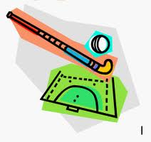
start

Finish
Write down the results on your record sheet
Dribbling
Name | Dribble using feet  Time | Dribble using hand | Dribble using a hockey stick and ball

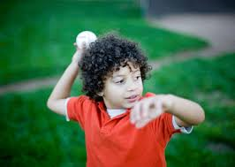
Playground Challenges

Target Throw

You will need
3 hoops of different colours – yellow, green, blue
6 bean bags 2 yellow, 2 green, 2 blue
Clipboard and record sheet

Yellow (3M away) Green (4M away) Blue (5M away)
Start

Challenge
Can you throw each of the bean bags into their correctly coloured hoop? To be successful in this challenge you must get ALL bean bags in the correct hoops when it’s your turn)

Write down the results on your record sheet.
Target Throw

Name | First hoop  (please tick) | Second hoop  (please tick) | Third hoop  (Please tick)

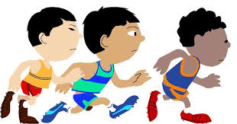
Playground Challenges
Shuttle Run

You will need
2 cones placed 10 M apart
Stopwatch
Record sheet

Start

Finish
How fast can you run to the cone and back 3 times?
Make sure your foot is level with the cone
Record your time

Shuttle Run

Name | 1st try (time) | 2nd try (time) | 3rd try (time)

Shuttle Run

