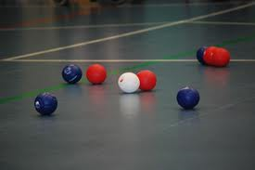
Boccia

- Teams of 3 pupils (and 1 reserve)
- Red side always starts first end by propelling the jack into court
- The captain chooses the player on their side to play the jack
- The jack must cross the V line to be in play
- The player who propels the jack ball also plays their team’s first coloured ball.
- A player from the opposing side then propels their first coloured ball.
- The side not closest to the jack must play until they either manage to get closer to the jack, or run out of balls. The side with remaining balls then propels them.
- The end is completed when all balls from both sides have been played.
- The end is scored by awarding one point for every ball of the same colour closer to the jack than the nearest opposing coloured ball.
- Second End
- Blue side then starts the second end.
- After both ends have been completed the winning side is the team with the higher accumulative score from both ends.
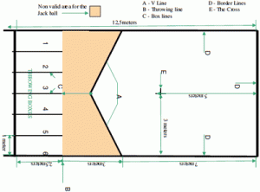
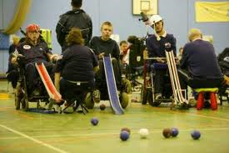

Web links www.bocciaengland.org.uk

Order of Play – Boccia
KS 2 (2/3 pupils in a team)

Students will play best of 2 ends. Points will be given 3 for a win, 2 draw and 1 for a loss
Pool A
- Orchards
- Hawthorns
- Durrington (red)
- Vale (yellow)
- West Park (blue)
- Laurels (red)
Pool B
- Durrington (blue)
- Downsbrook
- Laurels (white)
- Vale (green)
- West Park (yellow)
- Bramber

Court 1 | Court 2 | Court 3 | Court 4 | Court 5 | Court 6
2v1 | 3v6 | 4v5 | 2v1 | 3v6 | 4v5
3v4 | 6v1 | 2v5 | 3v4 | 6v1 | 2v5
6v4 | 2v3 | 1v5 | 6v4 | 2v3 | 1v5
4v1 | 5v3 | 6v2 | 4v1 | 5v3 | 6v2
5v6 | 1v3 | 4v2 | 5v6 | 1v3 | 4v2
Break | Break | Break | Break | Break | Break
1st V 1st | 2nd V 2nd | 3rd V 3rd | 4th V 4th | 5th V 5th | 6th V 6th
Results and presentation

KS 1 Order of Play (2 ends)
- Vale
- Downsbrook
- TAB (red)
- Hawthorns
- TAB (blue)

Court 7 | Court 8
1v2 | 3v4
1v3 | 4v5
1v4 | 5v2
1v5 | 2v3
2v4 | 3v5
Break | Break

