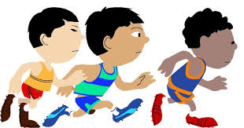
Year 1 /2 Multi skills Activities
- Standing Long Jump.
Challenge. Take off from 2 feet and land on 2 feet. Jumping over the furthest chalk line as you can.
4 mats required – 3 chalk lines on each mat. 1,2 and 3 points

XXXXX

- Target Throw (x 4)
Yellow (3M away) Green (4M away) Blue (5M away)

Can you throw each of the bean bags into their correctly coloured hoop?
- Obstacle Relay (across the sports hall)
Children sit on a mat in the centre. Jump over 2 hurdles (SAQ), touch the turning board, run all the way to the other end, in and out of the rounders’ posts, next persons turn.
XXXXX

- Speed Bounce (2 mats)
How many speed bounces can you do in 10 seconds? (if the central triangle is too high replace with bean bags)

- Dribble the ball using a Hockey stick and a ball from the start line in and out of the cones and back to the finish?
start

Finish

- Tri Golf - Dominoes. Putting.
Line up cones O O oooooooo
Children stand behind red cone and take it in turns to go to the white cone and hit towards the line of cones. If they hit the cone, then they collect the cone and bring it back. Aim is to collect as many cones as possible in the time.

7.Shuttle runs
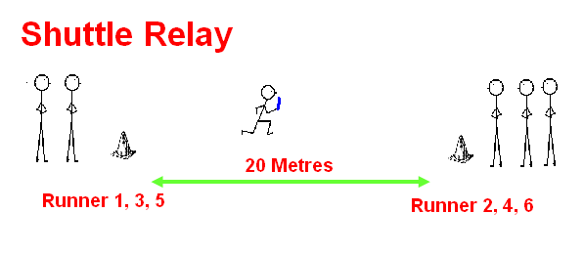
Teams run across the gym passing a relay baton

- New Age Kurling
Children stay behind a line with a stone each. Aim to get your coloured cones nearest the centre
- Tri Golf – Aiming towards the target

Equipment required
Long Jump mats
Chalk
12 hoops
6 rounders posts
2 turning boards
2 large cones
4 SAQ hurdles
4 speed bounce mats
2 small hockey sticks
4 airflow balls
2 play balls
2 relay batons
PA system

