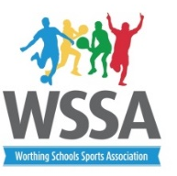
KS 2 Boccia
Durrington Juniors Wed 4th October 10-12.00
Pool A
1.Palatine Pink
2. Durrington white
3. Hawthorns
4.Vale Yellow
5.Durrington blue
6. Orchards
Pool B
7. Durrington red
8. Vale Green
9. West Park
10. Palatine purple
11. Laurels
Court 1 (Pool A) | Court 2 (Pool A) | Court 3 (pool B) | Court 4 (Pool B)
2v1 | 3v6 | 7v8 | 10v11
4v5 | 3v4 | 9v10 | 8v11
6v1 | 2v5 | 8v9 | 7v11
6v4 | 2v3 | 10v7 | 9v11
1v5 | 4v2 | 7v9 | 8v10
4v1 | 5v3 | 2v6
5v6 | 1v3
Short Break
Semi -finals and finals | Semi- finals and finals | 3rd and 4th from each group. | 5th and 6th from each group

