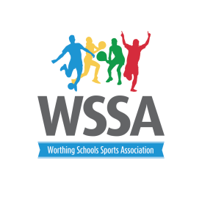

KS1 Virtual Indoor Athletics – Scoring

Events | 1point | 2 points | 3 points | 4 points | 5 points
Shuttle run  4x10m | More than  16 secs | Between  15.9 -15.0 secs | Between  14.9-14.1 | Between  14.0.-13.6 | Faster than 13.5
Speed Bounce | Between 0-12 | Between 13-15 | Between 15-17 | Between 18-20 | 21 or more
Long Jump | Less 1.-50cm | Between  51cm -99cm | Between 1.00m-1.24m | Between  1.25m -1.49m | 1.50m or more
Chest Push | Less than  2.49m | Between  2.5m – 2.99m | Between 3.00m – 3.49m | Between  3.50-4.00 m | 4.10M or more
Target Throw | 1-2  accurate throws | 3-5  accurate throws | 6-8  accurate throws | 9-11  accurate throws | 12  accurate throws

