GO EVENT PLAN
Event - Worthing

GO Event – The Gallops
Date | Tuesday 18th October 2016
Contacts | GRFF Contact:  Steph Pattinson (Youth Event Executive) 07712300537  Charlotte Allan (Campaign Coordinator) 0783453340  Brittany Pouresmaelieh (Tour Activator) 07429160316  Location Partners:  Julia Griggs, (The Vale First & Middle School Running Club) 07778509879  Sue Smith, School (Deputy Head) 019038723322  Alison Groves, (Worthing Schools PE & Sports Coordinator WSSA)  Lorna Tang  Additional Support:  TBC Vale Running Club, Students and Parents
Location of Event | The Gallops  Bost Hill and Vale Drive  Worthing  West Sussex  BN13 3DA
Special Guest
Participants | From Local Primary Schools
Expected Numbers
Registration Process | Through schools and the Vale Running Club
Timetable | Team on site – 07:15  Event set up – 07:30  Registration – 09:30  Introduction –10:00  Warm up –10:10  Runners to start line – 10:25  Event start – 10:30  Last runner crosses finish line – 10:50  Cool down – 10:50  Thank you-Goodbye – 11:00  Children Off site – 11:15  De-rig – 11:30  Team off site – 13:00
Route Map | 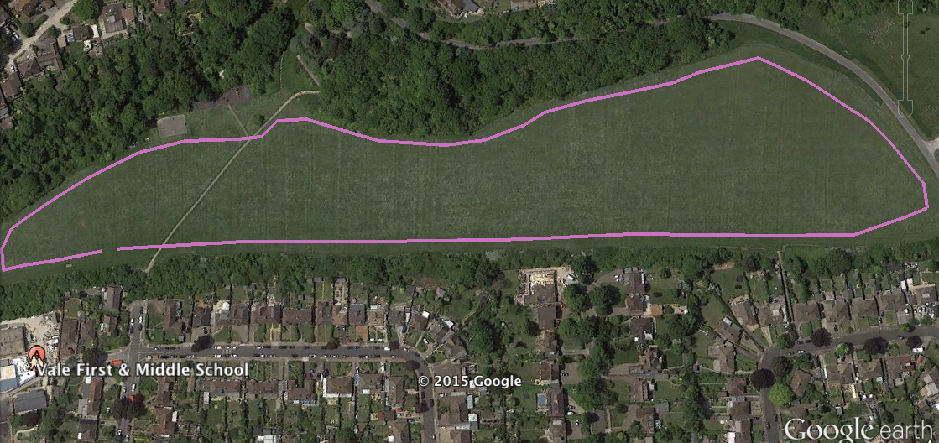
Zone Allocation | Zones School Total  A  B  C  D  E  F  Totals
Race Numbers | XX Generic GRFF race numbers, distributed at event
T-shirts | Total number of New Balance t-shirts:  Small Youth: XX  Large Youth: XX  To be sent to: (Please confirm address)
Branding | GRFF Team Provide:  - GRFF Van  - Dart Mascot  - New Balance Trainer Mascot  - 8 x GRFF Flying Banners  - 4 x New Balance Flying Banners  - 12 x A-F Zone GRFF Flying Banners  - 1 x Start GRFF Flying Banner  - 1 x Finish GRFF Flying Banner  - GRFF New Balance Scrim  - GRFF – Event Signage e.g. Registration & Arrows  - GRFF Finish tape  - GRFF Course tape  - GRFF Inflatable Gantry or NCGB gantry  - GRFF New Balance Marquee  - 2 x GRFF New Balance Pop Up A Frames  Local partner(s) provide:  Additional branding?
PR | CONFIRM LOCATION PARTNER IS CONTACTABLE BY PR AGENCY  Gardiner Richardson PR (Newcastle) to liaise with local media  Great Run and GRFF team to update social media (Twitter, Facebook & Instagram)  GRFF team to update website and gallery.
Photography Consent | Consent to be discussed with schools upon registration for event.  Children who cannot be photographed need to be easily identifiable (wear a sticker on their race number & identified to GRFF Team)
Missing Person Policy | This policy is covered in GRFF Tour Manual and is actioned by GRFF. One volunteer to be assigned as missing persons and idenitifed to children on the day.
First Aid | GRFF to Confirm British Red Cross  All GRFF Tour Activators are First Aid qualified.  Anyone treated will be referred to a GP or a qualified medic.  All accidents will be recorded in the accident book.  In the event of more serious issues the 999 or 112 services will be used.
Additional Requests | Someone to dress as Dart mascot, at least 5’8”

INEOS GO Run for fun ACTIVATION TOUR EVENTSHEET RISK ASSESSMENT. Dynamic risk assessment to be updated up to date of the event. To be completed and signed on the day of the event.
IDENTIFIED HAZARD | PEOPLE AFFECTED | EXISTING CONTROLS | RISK LEVEL | FURTHER MEASURES
Course Route | Participants | - All course marshalled and clearly signposted  - Extra signage in place to warn public of event | Low | - Additional marshals in position where runners may come into contact with public
Vehicles / Buses on site | Teachers, event staff and participants | - Buses to drop children in adjacent car park  - Marshals to walk children to start line  - Family members to park in car park | Low | - Schools are encouraged to walk to site to reduce buses/transport  - Marshals in place to monitor buses
Site plan of event | Teachers and participants | - Site plan designed  - Start and finish area designed and located in position to control children | Low | - Controlled registration zones to marshal children to start line  - Volunteers and marshals to assist
Park and Location | General Public, teachers and participants | - Schools and Teachers send event plan and detail prior to event | Low | - Vale School aware of event
Facilities including toilets | Teachers and participants | - School facilities | Low | - Schools will be responsible for children going into School
Crowd Control | Participants and spectators | - Designated area in place for spectators | Low | - Area cordoned off by stake and tape  - One volunteer assigned to manage zone
Completed by GRFF Team | Steph Pattinson (Youth Event Executive) |  | DATE | 10 August 2016
Completed by GO Event Partner |  |  | DATE

