Timings | Court 1  - Chesswood  - Hawthorns  - Durrington  - Whytemead | Court 2  - Orchards  - West Park  - Broadwater  - Downsbrook | Court 3  - Broadwater  - Durrington  - Vale  - English Martyrs | Court 4  - Hawthorns  - Whytemead  - Orchards  - AN other
 | 1v2 | 1v2 | 1v2 | 1v2
 | 3v4 | 3v4 | 3v4 | 3v4
 | 1v3 | 1v3 | 1v3 | 1v3
 | 2v4 | 2v4 | 2v4 | 2v4
 | 1v4 | 1v4 | 1v4 | 1v4
 | 2v3 | 2v3 | 2v3 | 2v3
 | First in each Pool  Play for 1st – 4th place | Second in each pool  Play for 5th to 8th | 3rd each pool  Play for 9th to 12th | 4th each pool Play for  13th to 16th
 | 1.  2.  3.  4. | 1.  2  3  4 | 1  2  3  4 | 1.  2  3  4
 | 1v2 | 1v2 | 1v2 | 1v2
 | 3v4 | 3v4 | 3v4 | 3v4
 | 1v3 | 1v3 | 1v3 | 1v3
 | 2v4 | 2v4 | 2v4 | 2v4
 | 1v4 | 1v4 | 1v4 | 1v4
 | 2v3 | 2v3 | 2v3 | 2v3
 | Results
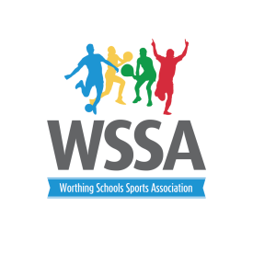
Boccia Legacy Games
Wednesday 21st June 1pm -3pm

