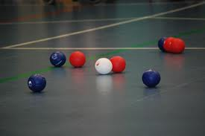
Boccia

- Teams of 3 pupils (and up to 1 reserve) SEND pupils
- Red side always starts first end by propelling the jack into court
- The captain chooses the player on their side to play the jack
- The jack must cross the V line to be in play
- The player who propels the jack ball also plays their team’s first coloured ball.
- A player from the opposing side then propels their first coloured ball.
- The side not closest to the jack must play until they either manage to get closer to the jack, or run out of balls. The side with remaining balls then propels them.
- The end is completed when all balls from both sides have been played.
- The end is scored by awarding one point for every ball of the same colour closer to the jack than the nearest opposing coloured ball.
- Second End
- Blue side then starts the second end.
- After both ends have been completed the winning side is the team with the higher accumulative score from both ends.
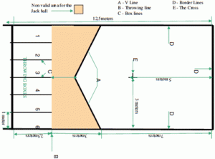
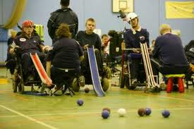

Web links www.bocciaengland.org.uk
Club link :Angmering multi -sport wasps club

